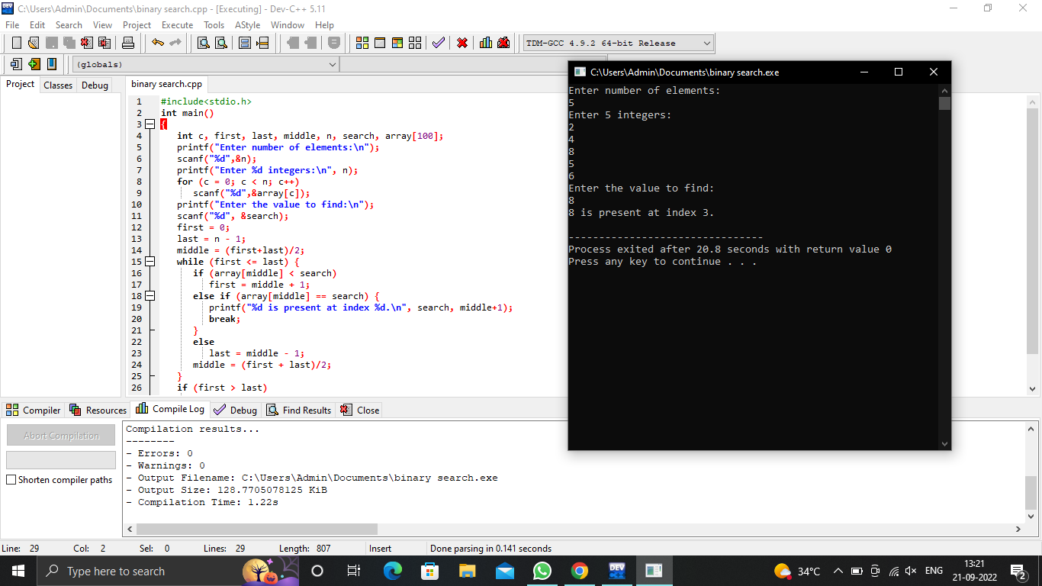

#include<stdio.h>

int main()

{

int c, first, last, middle, n, search, array[100];

printf("Enter number of elements:\n");

scanf("%d",&n);

printf("Enter %d integers:\n", n);

for (c = 0; c < n; c++)

scanf("%d",&array[c]);

printf("Enter the value to find:\n");

scanf("%d", &search);

first = 0;

last = n - 1;

middle = (first+last)/2;

while (first <= last) {

if (array[middle] < search)

first = middle + 1;

else if (array[middle] == search) {

printf("%d is present at index %d.\n", search, middle+1);

break;

}

else

last = middle - 1;

middle = (first + last)/2;

}

if (first > last)

printf("Not found! %d is not present in the list.\n", search);

return 0;

}